USBHID Device Plug-in Documentation

Version 1.0.0.1 by Sven Gijsen

Introduction

Later on the Optical Joystick feature was added to the program. This made the communication with the Optical Joystick (from Current Designs) possible. The user can calibrate/capture/filter and log the data stream. Furthermore it’s possible to emulate a mouse with the Joystick; this makes it easy to use the device in any Stimuli presentation software like E-prime/Presentation.

HOWTO Emulate the mouse with the Optical Joystick

The following explains how you can use the program to emulate the mouse actions with the optical joystick.

First we need to connect and roughly calibrate the optical joystick:

- Make sure that the optical joystick is connected to the optical cable, see below picture:

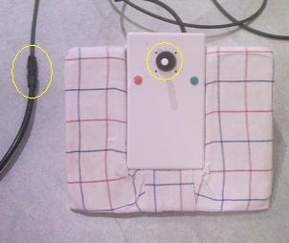

- Also make sure that the joysticks shaft is centered and stays in this position; this is an requirement for the first rough calibration to succeed, see above picture:

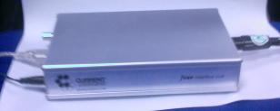

- Connect the Optical cable to the Electronic Interface, see above picture:
- Make sure that the Electronic Interface Mode Selection Wheel is positioned at number 5, see below picture:

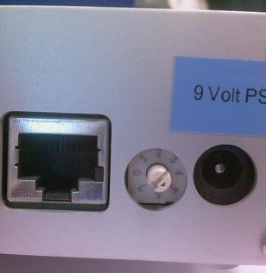

- Connect the USB cable from the Electronic Interface to the Stimuli PC, see below picture:

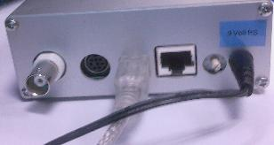

- Disconnect (if not yet disconnected) the Power supply from the Electronic Interface (see above picture), and connect it back again; the Electronic Interface roughly calibrates the device automatically during power startup (first 2 seconds). See next page:
Now we need to check whether communication between the joystick and the program is possible.

- Start the Hardware Communicator Program and select the “Optical Joystick” tab.
(The program folder can be fully copied from \\fdpsrv0015\Data\MRI-Lab Info\Hardware Communicator ).

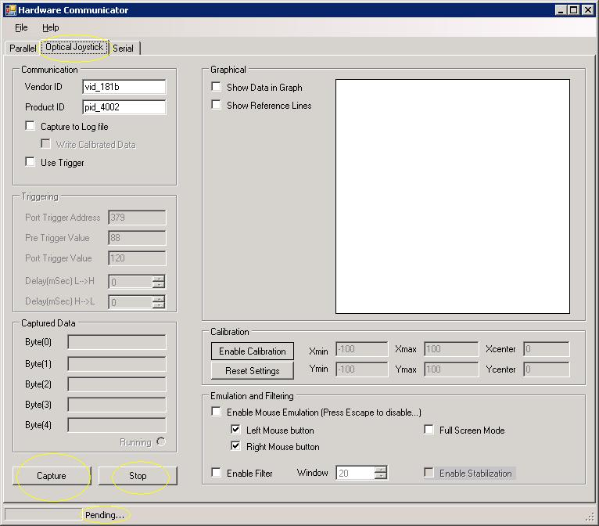

The program is already automatically started with the correct “Vendor ID” and “Product ID”

See next page.
The Vendor and Product ID can be found trough System Properties → Device Manager → USB HID Device → Properties → Details → Device Instance ID. See below picture:

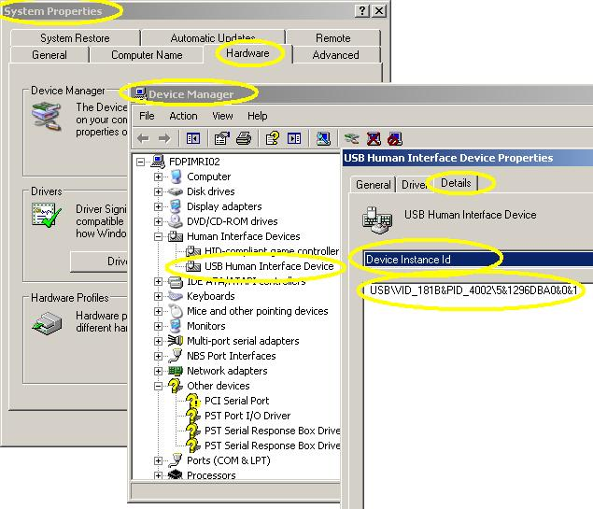

- Press the “Capture” button once on the “Optical Joystick” tab from the Hardware Communicator program. The programs status bar text changes from Pending…to HID Communication Active…See below picture:

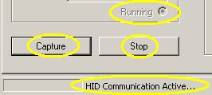

- Check/validate that the captured data is changing inside the “Captured data” frame when moving the joystick (only changes are captured).
- Press the “Stop” button on the “Optical Joystick” tab. The programs status bar changes again from HID Communication Active…to Pending…

See next page.
The communication is now checked and now we can further calibrate the joystick.

- Select the “Show Data in Graph” and the “Show reference Lines” checkbox, to show the results of the joystick movement inside a graph together with some reference lines.
- Select the “Enable Calibration” button, its back color turns green meaning that the calibration is now activated.
- Press the “Capture” button on the “Optical Joystick” tab. The programs state changes from Pending…to HID Communication Active…in the status bar.

During calibration the program reads the optical joystick data stream (X, Y position and button presses) and adapts the minimal and maximal value for X and Y found (see Calibration frame) during (calibration) capture. It’s therefore important to move the joystick during this calibration to the most/fully outer corners! By this the program can calibrate itself to the new/current X/Y min/max values and use these values for further capturing!
During the calibration process you’ll notice that the small box inside the Graph moves together with the movement of the joystick. When the joystick is fully calibrated the joystick can move inside a circular area, see below dashed area!

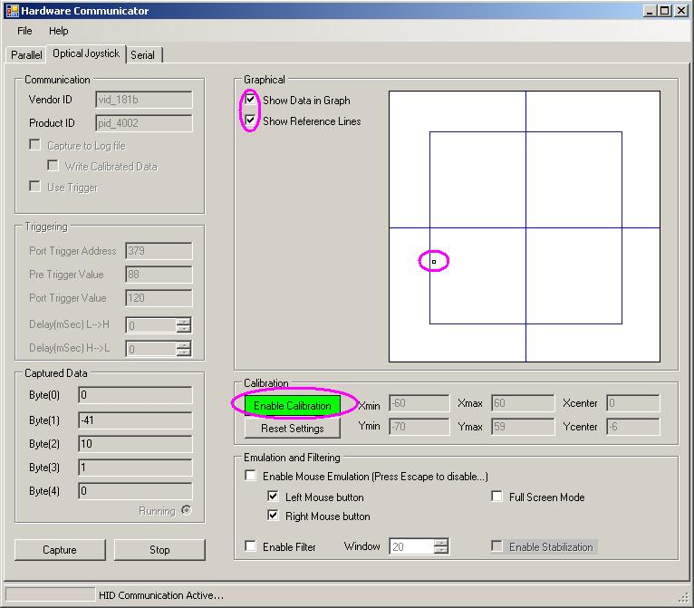

See next page…
- If the joystick is fully calibrated you can click the “Enable Calibration” button to disable the calibration, the calibrated settings remain in memory as long the program is running.
- Press the “Stop” button on the “Optical Joystick” tab. The programs status bar changes again from HID Communication Active…to Pending…

By now the joystick is ready for mouse emulation, but we’ll still need to configure some setting, see “Emulation and Filtering” frame:

- If you want to activate the mouse (pointer and button presses) emulation (during an active capture process) you should check the “Enable Mouse Emulation”. Because the joystick then interferes with the mouse movement you can press the “Escape” key to uncheck this option and disable the mouse (pointer and button presses) emulation (during an active capture process)
- Optionally you can also disable the left or right mouse button emulation.
- “Full screen mode” makes it possible to point the mouse arrow to the outer corners of the screen trough mouse emulation with the optical joystick. When this checkbox is not selected the circular area in which you can move the mouse arrow over the screen is limited by a circular area which fits inside the screen rectangle and therefore cannot reach the outer corners. If you select this option then the circular area in which the mouse arrow can move is expanded to outside the screen rectangle (this is also represented by the reference box inside the graph!).
- To create a smooth transition of the movement of the mouse pointer you should check the “Enable Filter” checkbox. This tells the program to keep track of a history of an amount of “Window” captured records and use these to mean the X/Y signal to create a smooth transition.
- Because the SNR of the optical joystick signal is pretty poor you may also select the “Enable Stabilization” checkbox which will ignore minor captured movements (which occur due to the noise level!) and keep the mouse pointer at it’s current position.

After you have checked, calibrated and configured the program you should start your stimuli presentation software. Set the software to make use of the standard mouse events.
- Start you stimuli script and press the “Capture” button to start the mouse emulation using the optical joystick. Press the “Escape” key to disable the mouse emulation.
- After the measurement you should press the “Stop” button again to stop the capture process and closing down the program.

